**United Nations Development Programme**

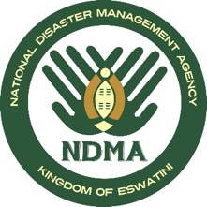

**PROGRAMME DOCUMENT**

**Country: Eswatini**

**CONCEPT NOTE**

**Project Title:** Emergency Response to Floods and Landslides 2021

**Implementing parties:** UNDP & NDMA

**Programme Period:** December 2019 – April 2020

**Project Title:** Emergency Response to Floods Landslides 2021

**Project ID:** _________________

**Project Duration:** 6 Months

**Management Arrangement: _DIM________________**

**Total Budget** **US$ 100,000**

**Allocated resources:** ____________

* Government ____________
* Regular (TRAC 1.1.3) US$ 100,000
* Other:
  + Donor _________
  + Donor _________
  + Donor _________
* In kind contributions _________

Unfunded budget: _________

**Agreed by**

|  |  |  |  |
| --- | --- | --- | --- |
| ***On behalf of*** | ***Signature*** | ***Date*** | ***Name/Title*** |
| UNDP Eswatini |  |  |  |

1. **Situation Analysis**

Eswatini remains vulnerable to extreme weather events and associated disasters exacerbated by climate change. The tropical cyclone (TC) Eloise that developed over the South West Indian Ocean on 14th Jan 2021 made land fall over Mozambique Saturday morning 23rd January 2021 and tracked west – south westwards towards the Kingdom of Eswatini affecting areas including Eswatini, Northern Kwanzul Natal and Mpumalanga Provinces. The Tropical Cyclone brought heavy rains (see map on the left) ranging from a minimum 90mm – 385 mm accumulated over 24 hours along its path and wind speeds reaching 110km/hr in some areas. The last Tropical Cyclone (TC) to hit Eswatini was in 1984 where a considerable damage to infrastructure and loss of life was witnessed. Recent Tropical Cyclones experienced in the Southern African Region spared the country while ravaging some neighbouring countries.

[1]

**A map of areas most likely to be severely affected by cyclone Eloise**

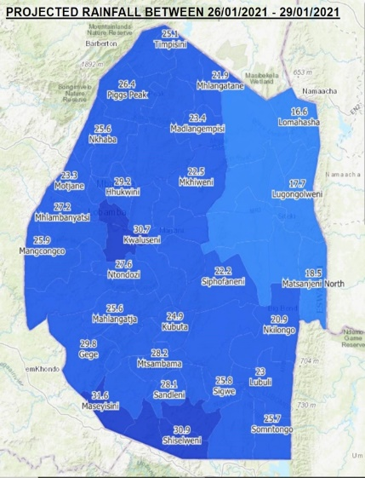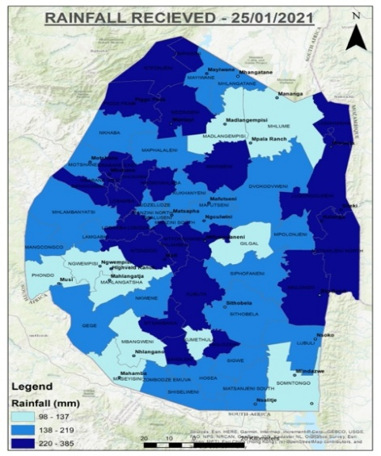As a result of the cyclone, high intensity rainfall within a short period has been received causing flash floods, waterlogging, damage to build infrastructure and environmental degradation (soil erosion and loss of biodiversity). River flooding has caused damage to bridges and loss of life due to drowning. Further, strong winds have caused damage to infrastructure including telecommunication and power systems, breaking of trees causing accidents; and thunderstorms accompanied by lighting that has caused danger to humans, animals and infrastructure. All major rivers in the country reported flooding including streams (both perennial and seasonal) resulting in washing away of several low-level bridges and mud slide especially along the road sides. Rock falls were also reported damaging people’s houses and road infrastructure. Flooding was also reported in urban areas causing damage to parking areas and urban infrastructure.

  

*Pictures showing loss and damage due to the extensive rainfall received during the period 23-24 January 2021*

A total of 266 houses have been damaged and 1410 persons displaced by the floods and landslides. Different parts of the country received varying amounts of rainfall (high intensities possible) and experience the very strong winds at the passage of the storm coupled with the passing of a cold front. These strong winds have also impacted different locations differently depending on altitude and orientation of the country mountains.

According to the government flash report of 25th January 2021, the following incidents were recorded:

* All major rivers of Eswatini were flooded including streams (both perennial and seasonal), causing significant damages to houses and infrastructure both in urban and rural areas.
* The cyclone displaced 1,410 people in all the four regions of the country.
* Water supply systems were damaged, affecting sources of potable water.
* Damaged communication and power lines are still being restored in about 85 areas where faults were reported.
* Mudslides/landslide were reported in areas of Mncitsini, Manzana, Mangwaneni, Mpolonjeni and others.
* The heavy rains caused extensive damage to all gravel roads around the country, with low lying bridges flooded and some completely washed away.
* Two people drowned and a number of vehicles washed away
* Flooding was also reported in urban areas causing severe damages to parking areas and road infrastructure including the Mbabane mall and Emfuleni resort.

It is worth mentioning that the information listed above is the result of a preliminary assessment. NDMA with the support of Ministries and international and national partners (including UNDP Eswatini) is currently carrying out a sectoral assessment of damages and losses. The final report is expected to be delivered on Monday 1 February 2021. It will present a more detailed picture of the impact of the TC Eloise, which is expected to be more important.

Government through NDMA has requested UN for technical assistance in planning and coordinating the response and recovery to the cyclone disaster. This is especially important because extreme weather events such as rapid on set of Tropical Cyclone have not been responded to by NDMA since its establishment and yet they can be catastrophic.

In support of Government and humanitarian actors’ efforts to manage the extreme weather events associated with the cyclone and rainy season, UNDP is strengthening Disaster Risk Management Coordination capacity. The programme focuses on providing or enhancing the capacity of government to respond to natural disasters in the changed COVID 19 context, mapping and improving critical disaster management infrastructure, and providing disaster risk management technical advisory services to the humanitarian and development community.

It is against this background that UNDP using its integrator role and technical leadership on multisectoral engagement on disaster risk management is seeking services of disaster risk management Coordination Specialist to provide technical DRR advisory and coordination supports to NDMA to undertake a rapid assessment, producing flash updates and Situational Reports. The preparedness planning and response for Eloise will serve as a capacity building exercise for NDMA and local partners.

In response to the multi-disasters facing Eswatini since March 2020 including COVID-19 and flash floods, government is stepping up activation of NEOC at different levels including Tinkhundlas to provide the needed coordination for preparedness, response and recovery including Disaster Management Committees at Tinkhundla and sector level, disaster risk communication; rehabilitation of drainage systems; mapping and equipping community safe havens; ensure surface; water monitoring on key water systems are functional, flood modelling and forecast. In addition, government has undertaken the following measures:

1. A joint operation has been set up between the NDMA and National Meteorological Service for close storm watch and monitoring, early warning and provision of regular information updates, daily press briefings (government and private) and bulletins. The Multi Hazard Contingency Plan has been activated by allowing all sectors to update the plan as well as to be ready to implement activities. The plan will be continuously updated as more information is made available and storm evolution ad mutation.
2. Different humanitarian actors have been sensitized and advised to activate local contingency plans, preposition of emergency stocks.
3. Communities alerted through radio, regional disaster coordination and traditional structures
4. Emergency ICT institutions sensitized to collaborate with Eswatini Electricity Company and ensure minimal power interruptions of power supply to all essential communications sites
5. NDMA has activated volunteers in all 59 Tinkhundla who can be contacted for assistance as first responders. Their numbers together with those of NDMA Regional Coordinators will be made available in all regions. Others who can be contacted are Chiefdom Development Committees / Disaster Risk Management Committees.
6. A rapid assessment is underway to determine the extent of the cyclone impact to inform emergency response requirements.

The NDMA has identified and proposed that Boarding Schools should be used as evacuations areas or safe heavens. The Ministry of Education is currently being engaged to ensure preparedness of these areas. While safe heavens have been considered, due to COVID-19, efforts are being made to keep people in their families and household residences.

While the full impact of the floods has not been yet determined, preliminary reports indicate significant damage to critical infrastructure with sections of roads cut off across the country paralyzing transport and hampering humanitarian relief efforts. Further, the floods have damaged a large number of critical infrastructure including bridges, dams, schools, health facilities and water sources.

|  |  |  |  |
| --- | --- | --- | --- |
| National Situation of Damages to Houses (25 January 2021)[2] | | | |
| Inkhundla | **Households** | **Number of people** | **Impact** |
| Hhohho | 34 | 170 | Household Damage |
|  |  |  |  |
| Lubombo | 22 | 110 | Household Damage |
| Manzini | 77 | 425 | Household Damage |
| Shiselweni | 133 | 705 | Household Damage |
| Total | 266 | 1410 |  |

1. **Justification**

Although flooding is not a new phenomenon in Eswatini, the intensity of the current rains and the extent of flooding is unprecedented. The magnitude of the current floods far outweighs the level of the country’s preparedness to mitigate the effects of the floods leading to massive loss of assets, lives and livelihoods. With continuing rains, more people will be rendered homeless, further infrastructural damage, food shortages, and loss of livelihoods expected.

The current floods situation has come at a time when the country is grappling with the second wave of the COVID19 pandemic compounding the vulnerability of those at risk. The floods have therefore found communities in an already vulnerable position with their coping mechanisms compromised, and limited potential support from other parts of the country with road infrastructure damaged, cost of moving food and other supplies to meet the food and health needs of the affected people is likely to increase moreover it is unknown to what extent.

The Government of Eswatini, humanitarian agencies such as the Red Cross Society, World Vision and other development partners, are currently providing emergency assistance focusing on the immediate lifesaving interventions including food, alternative shelter, medical care and evacuation. However, the potential impact of this disaster is mostly unknown, it is against this background that the Government has requested the UN system and development partners to support floods response and recovery which requires a comprehensive response and recovery needs assessment and coordination. An assessment of recovery needs by sector and geographic area would allow government and partners to identify interventions that might support coordination of government response; and early recovery and building back better in the context of COVID19. This could inform efforts to restore basic services functionalities, reconstruction of critical infrastructure to more resilient standards and overall addressing underlying vulnerabilities while restoring livelihoods and structures, in line with build-back-better principles.

UNDP has supported government in creating an enabling environment for Disaster Risk Management Building of National Capacities including establishment of the National Emergency Coordination Center under National Disaster Management Agency. Thanks to capacity building efforts and technical support, the NEOC has been able to provide multi-sectoral and government coordination of natural disasters including COVID 19 pandemic. This notwithstanding, government requires additional support to enable NDMA and the Operations center effectively coordinate preparedness, response and recovery efforts to multi-disasters.

A detailed assessment of the extent and effects of the current floods is essential to determine the full economic and human impact of the floods on people and their livelihoods as well as to inform most effective strategies for reconstruction, rehabilitation and overall risk-informed recovery. Strong coordination is critical to ensure that any response and recovery initiatives are addressing the real needs of the flood affected populations as well as putting in place measures to increase resilience to future disasters.

Detailed assessment of the consequences and causes of the disaster will reveal exposure and vulnerability patterns that could be addressed through the recovery process by planning to build-back-better to prevent new risks and mitigate pre-existing ones.

Coordination capacity for response and recovery is varied across the affected Tinkhundlas, many of the whom have been trained but do not hold meetings frequently which affects their coordination capacities when disasters occur. In addition, most Tinkhundlas do not have adequate resources to allow efficient emergency response to disasters insufficient coordination among organizations and stakeholders has resulted in fragmentation of responsibilities for action. Tinkhundlas that have had recurring disaster incidents have fairly organized and experienced Disaster Management Committees than the others due to previous emergency response and recovery interventions.

This concept therefore seeks US$100,000 to allow UNDP Eswatini to provide the needed support to government to effectively respond to the cyclone related emergency response and recovery planning.

1. **Project objectives and Outputs**

In relation to the request from Government, UNDP intends to support conducting a rapid needs assessment to inform early recovery from disaster and rebuilding resilience assets. The assessment results will also contribute to the ongoing COVID19 recovery needs assessment.

**Overall Objective**

To strengthen coordination mechanisms and establish early recovery needs of affected communities and response.

**Specific Objectives**

1. Generate data and relevant information on recovery needs in different sectors to inform integration of early recovery in humanitarian assistance.
2. Develop a plan of action for sector specific actions to support recovery and resilience building
3. Analyze the economic and human needs for recovery and to identify opportunities to build back better, prevent future risk and mitigate existing ones.
4. Activate disaster response coordination mechanisms at national, Tinkhundla and community level

**Outputs**

1. Recovery Needs Assessment Report (RNA)
2. Functional disaster response structures at national, Tinkhundla and community level to coordinate response and early recovery measures.
3. **Management arrangement**

The Project management arrangement shall be that UNDP Eswatini and NDMA will work closely with significant sectors affected by the cyclone related floods and landslide disasters. It will employ a Direct Implementation Modality (DIM) based on UNDP Programming guidelines

1. **Workplan and Budget**

|  |  |  |  |  |  |  |  |  |  |
| --- | --- | --- | --- | --- | --- | --- | --- | --- | --- |
| Expected output | Key Activities | Time frame | | | | | Responsible party | Budget description | Amount (USD) |
|  |  | Feb | Mar | Apr | May | June |  |  |  |
| Output 1: Enhanced Coordination Capacity for response and recovery from floods and landslides  *Indicator:*  Improved coordination mechanisms between stakeholders and partners  Number of coordination meetings facilitated | 1. Provide technical support to national and Tinkhundla structures for coordination and information sharing | X | X | X | X | X | UNDP, NDMA | Workshops and Training (75700); Communications and audio-visual equipment (72400)  Travel cost (71600)  Consultant costs (71300) | 10,000 |
| 1. Provide technical assistance to facilitate data collection and monitoring, and information analysis, sharing and management, | X | X | X | X | X | UNDP, NDMA | Facilitation for NDMA volunteers (75700);  Travel cost (71600)  Consultant costs (71300)  Communications and audio-visual equipment (72400) | 15,000 |
| 1. Sensibilizations and establishment of mechanisms on Disaster Data (Reporting storage analyses and management) |  | X | X | X |  | UNDP, NDMA | 10,000 |
| Output 2. Multi-sectoral assessment to determine early recovery needs response measures. | 1. Facilitate joint assessments to determine specific community recovery needs to enhance resilience of the affected population. | X | X | X |  |  | UNDP, NDMA | Multi-sectorial Meetings (75700)  Travel cost (71600);  Equipment and furniture (72200)  Consultant costs (71300) | 35,000 |
| 1. Support early recovery planning processes and the development of multi-sectorial early recovery plan for transition from relief to early recovery and mid-term recovery and reconstruction |  |  |  |  |  | UNDP, NDMA | Workshops and Training (75700); Consultant (71300)  Travel cost (71600)  Communications and audio-visual equipment (72400) | 30,000 |
|  | | | | | | | | | **100,000** |

1. NDMA 2021: Tropical Cyclone Eloise Preparedness Plan
2. NDMA 2021: Tropical Cyclone Eloise Situational Report-25 January 2021